**FALL DETECTION SYSTEM USING**

**YOLOv5**

**TEAM MEMBERS:**

NAVANEETH AMARNATH

AAYUSH KRISHNA

LAKSHMI RAJEEV

RENIL AUGUSTINE BABY

**GUIDE**

GEETHA S.

**School name:** School of Computing Science and Engineering

**Faculty name (ERP No):** S.Geetha, (50587)

**Academic Year:** 2022-2023 (Winter Semester 22-23)

**Title of the project:** Fall Detection Using

YOLOv5

**Number of students involved in this project:** 4

| Navaneeth Amarnath 20BRS1195 | Aayush Krishna 20BPS1102 |
| --- | --- |
| Renil Augustine Baby 20BCE1826 | Lakshmi Rajeev 20BAI1294 |

**TABLE OF CONTENT**

**Chapter 1: Introduction**

1.1 Abstract

1.2 Recentness

1.3 Problem Definition

1.4 Statistics

1.5 Cause of Falls

1.6 Motivation

**Chapter 2: Methodology**

2.1 Project Component Specification

2.1.1 Software Components

2.1.2 Hardware Components

2.2 Existing Systems

2.3 Limitations of the previous Systems

2.4 Specific Problems that can be solved

2.5 Fall Detection

2.5.1 Input

2.5.2 Processing

2.5.3 Output

**Chapter 3: Architecture**

3.1 YOLOv5

3.2 ESP32 camera

3.3 Firebase

3.4 Proposed Model

**Chapter 4: Implementation**

4.1 Camera Input

4.2 Detection

4.3 Alert System

4.3.1 Telegram

4.3.2 Whatsapp

4.4 Database

**Chapter 5: Results**

**Chapter 6: Outcomes**

**Chapter 7: Single Unique Factor**

**Chapter 8: Future Work**

**Chapter 9: Sample Codes**

**Chapter 10: Conclusion**

**Chapter 11: References**

**List Of Figures**

Fig 1.4.1 Where fall mainly occurs

Fig 1.4.2 Statistic of Falling among normal and elderly people

Fig 2.5.3.1 Falling Examples

Fig 3.1.1 YOLOv5 Diagram

Fig 3.2.1 ESP32 Pin Diagram

Fig 3.3.1 Architecture of our Model

Fig 4.1.1 ESP32 Code

Fig 4.2.1 Detection Code

Fig 4.3.1.1 Telegram API Code

Fig 4.3.2.1 Whatsapp API Code

Fig 4.4.1 Firebase Intialization Code

Fig 4.4.2 Firebase condition to store image and send URL to user

Fig 5.1 Camera

Fig 5.2 Camera Shell

Fig 5.3 Camera Shell

Fig 5.4 Camera inside Shell

Fig 5.5 Camera inside Shell

Fig 5.6 No Detection of Fall

Fig 5.7 Detection of Fall

Fig 5.8 Telegram Alert

Fig 5.9 Whatsapp Alert

Fig 5.10 URL saved photo

Fig 5.11 Photo stored in Database

Fig 5.12 YOLO Results

**List Of Symbols**

NPHCE National Program for the Health Care of the Elderly

WHO World Health Organization

FOF Fear Of Falling

NHFS-4 National Health and Family Survey

YOLO You Only Look Once

CNN Convolutional Neural Network

ESP32 Espressif Systems 32

SPP Spatial Pyramid Pooling

PAN Path Aggregation Network

BiFPN Bidirectional Feature Pyramid Network

I2C Inter-Integrated Circuit

SPI Serial peripheral interface

UART Universal Asynchronous Receiver-Transmitter

ADC Analog-to-Digital Conversion

DAC Digital-to-Analogue Converter

PWM Pulse-Width Modulation

PMU Power Management Unit

API Application Programming Interface

**Chapter 1: Introduction**

1.1 Abstract

The number of persons above the age of 60 years is fast growing, especially in India. India as the second most populous country in the world has 104 million people at or over the age of 60, constituting above 7.53% of total population. The problems faced by this segment of the population are numerous owing to the social and cultural changes that are taking place within the Indian society. The major area of concern is the health of the elderly with multiple medical and psychological problems. Elderly falls have been a concern for many years, but it has become an increasingly important issue in recent decades, particularly as the global population has aged. With the increasing number of older adults, the risk of falls and their consequences has become a major public health concern. According to the World Health Organization (WHO), falls are the second leading cause of accidental or unintentional injury deaths worldwide, and around 37.3 million falls that are severe enough to require medical attention occur each year. Falls are the leading cause of injury-related deaths among people aged 65 and above. The product developed is focused on this problem.

1.2 Recentness

The number of elderly people in India, who are classified as those 60 and above, is projected to be roughly 120 million by 2021, or around 8.6% of the entire population. Due to the tendency of India's population getting older, this number is anticipated to rise in the upcoming years. In India, the percentage of the old population varies by state. 15.4% of Kerala's population is 60 years of age or older, continuing the state's record for having the largest percentage of elderly people. Contrarily, with 6.5% and 6.8% of the population over 65, respectively, the states of Bihar and Uttar Pradesh continue to have a lower percentage of the elderly. Also, there are gender variations among the old in India, with women continuing to make up a higher share of the elderly population.

The development of novel technology and interventions to lessen falls and their effects, as well as fall prevention and management techniques, have received more attention in recent years. In order to design efficient interventions, identify risk factors for falls among the elderly, and spread best practices and guidelines for fall prevention, researchers and public health professionals have been working on these issues. Due to the country's rapidly ageing population and the recognition of falls among the elderly as a serious public health issue, falls prevention measures have been developed and put into practise in India. As I said previously, the National Program for the Health Care of the Elderly (NPHCE) in India has recognised falls prevention as an essential area for effort.

Ambulation was reported as the most common activity engaged in at the time of fall. Talbot et al, in their study reported 31.5%falls occurring while ambulating, 9.3% while transferring and 7.4% while on stair/curbs. This is also consistent with other studies. In order for adults, the majority of falls occurred while walking on a level surface during ordinary daily activities in the absence of hazardous behaviour. According to a study published in the Indian Journal of Community Medicine in 2018, falls were the leading cause of injury among the elderly in India, accounting for 38.9% of all reported injuries. The study also found that the prevalence of falls increased with age, and that women were more likely to experience falls than men. Another study published in the Indian Journal of Gerontology in 2018, which was conducted in a rural area of India, found that falls were the most common cause of injuries among the elderly, accounting for 44.8% of all reported injuries. The study also found that the majority of falls occurred indoors, and that the most common types of injuries resulting from falls were fractures and bruises. Furthermore, according to a report published by the Ministry of Health and Family Welfare, Government of India in 2019, falls were one of the top ten causes of morbidity and mortality among the elderly in India. The report noted that falls often result in serious injuries and disabilities, and can have significant economic and social costs.

1.3 Problem Definition

The primary cause of both fatal and non-fatal injuries among elderly people is falls. In fact, among seniors, falls were the second most common reason for injury-related hospitalization. According to National Crime Records Bureau data, injuries caused the deaths of more than 40,000 elderly people in 2020. According to several epidemiological studies on the elderly population, 1.7% of people had injuries. In fact, among seniors, falls were the second most common reason for injury-related hospitalization. One study found that of elderly residents who had suffered a fracture due to a fall, nearly two-thirds had fallen repeatedly within the year before the fracture occurred. There are many factors that may contribute to an elderly person's risk of falling, including health issues and medication side effects, the environmental factors such as stairs or slippery floors, and social factors such as loneliness and depression. So we will be creating a device which can monitor the elderly when they are about to fall and alert those emergency contacts immediately when assistance is required.

1.4 Statistics

It is reported that 38.4% of older persons reported fear of fall and FOF was reported more by older adults with a history of fall. In the previous studies FOF has been reported in approximately 30%-55% of older people and approximately one third of them report restricting their activities. It tends to occur more often in women than men, increasing with age, illness, and in older adults who have fallen in past years. The results of this study indicate that falls are a prevalent public health problem in Indian older adults, especially women. The study provides insight into the circumstances and consequences of falls in older adults.

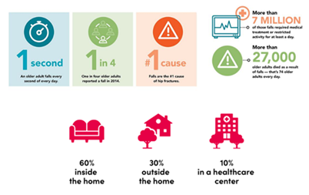

Fig 1.4.1 Where fall mainly occurs

In recent years, increasing focus has been placed on fall management and prevention strategies, as well as the development of novel technology and interventions to reduce falls and their impacts. Researchers and public health professionals have been working on these topics in order to devise effective interventions, identify risk factors for falls among the elderly, and propagate best practices and guidelines for fall prevention. Falls prevention strategies have been created and put into practise in India as a result of the nation's rapidly ageing population and the identification of falls among the elderly as a critical public health issue. As I indicated previously, the National Program for the Health Care of the Elderly (NPHCE) in India has highlighted falls prevention as a vital area for endeavour. The frequency of falls among senior people in India was higher in rural regions than in urban areas, with rates of 5.1% and 4.5%, respectively, according to the NHFS-4. Elderly people in India frequently get serious injuries from falls, including fractures and head injuries, which can impair their quality of life and cause disability. Elderly people in India are falling more frequently, which emphasises the need for healthcare interventions and fall prevention techniques that are efficient.

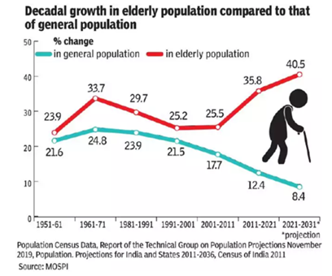

Fig 1.4.2 Statistic of Falling among normal and elderly people

1.5 Cause of falls

The causes of falls are known as risk factors. Although no single risk factor causes all falls, the greater the number of risk factors to which an individual is exposed, the greater the probability of a fall and the more likely the results of the fall will threaten the person's independence. Many of these risk factors are preventable. As obvious as it may sound, a lack of knowledge about risk factors and how to prevent them contributes to many falls. Some people believe that falls are a normal part of aging, and as such are not preventable. Lack of knowledge leads to lack of preventive action, resulting in falls. Discussed below are five key risk factors of falls among older adults. Preventive measures for each factor are briefly listed.

1. Osteoporosis: Osteoporosis is a condition wherein bones become more porous, less resistant to stress, and more prone to fractures. Caused by hormonal changes, calcium and vitamin D deficiency, and a decrease in physical activity, osteoporosis is a chief cause of fractures in older adults, especially among women.
2. Lack of Physical Activity: Failure to exercise regularly results in poor muscle tone, decreased strength, and loss of bone mass and flexibility. All contribute to falls and the severity of injury due to falls.
3. Impaired Vision: Age-related vision diseases can increase the risk of falling. Cataracts and glaucoma alter older people's depth perception, visual acuity, peripheral vision and susceptibility to glare. These limitations hinder their ability to safely negotiate their environment, whether it be in their own home or in a shopping mall. Young people use visual cues to perceive an imminent fall and take corrective action. Older adults with visual impairments do not have this advantage to the same extent.
4. Medications:Sedatives, antidepressants, and antipsychotic drugs can contribute to falls by reducing mental alertness, worsening balance and gait, and causing drops in systolic blood pressure while standing. Additionally, people taking multiple medications are at greater risk of falling.
5. Environmental Hazards: At least one-third of all falls in the elderly involve environmental hazards in the home. The most common hazard for falls is tripping over objects on the floor. Other factors include poor lighting, loose rugs, lack of grab bars or poorly located/mounted grab bars, and unsteady furniture.

Although there are literally hundreds of reasons why people fall, some risk factors are more common and easily remedied by those others.

1. Acute Illness: Falls can be an indication that the person is unwell. The person who develops an acute illness such as a chest or ear infection may well present with a fall. Treating identified infection reduces falls risk. It’s important to be aware that many older people have asymptomatic bacteriuria. A urine dipstick reading is an unreliable indicator of urinary tract infection in older people and treating an older person for urinary tract infection in the absence of urinary symptoms exposes the person unnecessarily to the hazards of antibiotic therapy. Erroneous diagnosis or urinary tract infection also causes delays in finding out the reasons why the person is really falling.
2. Undiagnosed Disease: Falls can indicate that the person has suffered a mild stroke or is developing Parkinson’s disease. Observation of facial changes such as a lopsided smile or a face that is devoid of expression can alert you to such problems. Simple checks of limb function and power can confirm such suspicions and enable you to make an appropriate referral.
3. Long Term Condition: The person with a long-term condition may be falling because the condition is worsening, or because the person is not complying with medication and treatment. If you suspect this check, optimize treatment if you are able or refer for further investigations and treatment.
4. Poor nutrition and Hydration: Falls can occur if a person is dehydrated or malnourished. Observing the person, how clothes fit and if rings seem loose can alert you to the possibility of weight loss and enable you to address this. You can also observe the person for signs of dehydration and enquire about fluid intake. Correcting nutritional and fluid deficits improves health and reduces falls risk.
5. Visual Problems: Poor vision increases the risk of falls. If a person cannot see clearly, he or she is at greater risk of falls. Some age-related changes are not yet treatable. The best we can do is to prevent Further deterioration. Many older people have treatable eye conditions. Researchers found that 76% of hospital inpatients admitted following a fall had poor vision; 40% needed glasses, 37% had cataracts, 14% senile macular degeneration.

1.6 Motivation

* To decrease senior fall risk. to constantly monitor senior citizens from any location.
* Help the elderly as soon as possible.
* Can provide seniors and their carers peace of mind, lowering worry and raising general quality of life.
* Can also give useful information to medical experts, allowing them to comprehend and avoid falls in the senior population.

**Chapter 2: Methodology**

2.1 Project Component Specification

2.1.1 Software Components

YOLOv5s model: YOLO (You Only Look Once) is a popular object detection algorithm that aims to detect and classify objects in real-time from images and videos. YOLOv5 is the latest version of the YOLO family of models, which was introduced in 2020. YOLOv5 is based on a new architecture that uses a single convolutional neural network (CNN) to simultaneously predict bounding boxes and class probabilities for objects in an image. The technique "only looks once" at the image since it only does one forward propagation loop through the neural network before making predictions. Detected products are then delivered following non-max suppression (which ensures that the object detection algorithm only identifies each object once). This new architecture is more accurate and faster than previous versions of YOLO.

2.1.2 Hardware Components

Esp32 camera: The ESP32 Camera is a low-cost, low-power camera module based on the ESP32 chip. It integrates a high-sensitivity camera sensor, a microSD card slot, and Wi-Fi capabilities, making it an excellent choice for IoT applications that require image capture and processing. The ESP32 Camera module comes with a variety of features, such as: High sensitivity camera sensor, Wi-Fi connectivity, MicroSD card slot, Low power consumption, Easy integration. With its high sensitivity camera sensor and Wi-Fi capabilities, it can capture high-quality images and stream them over the internet, enabling real-time monitoring and analysis. Additionally, the microSD card slot allows for local storage of images and videos, making it ideal for applications that require offline image processing. The general camera module and the fixing charges are costly and not feasible by everyone. Thus, we have used an esp32 camera as our hardware making the entire product cheap and feasible for the customers.

2.2 Existing Systems

There are several ways in which fall detection systems for the elderly have been solved using existing systems by integrating various sensors and algorithms into wearable devices or smart home systems. These systems use various technologies to detect falls, including accelerometers, gyroscopes, and pressure sensors.

Wearable Technology: Using wearable technology, such as smartwatches or fitness trackers, which are fitted with sensors to monitor the wearer's movements, is one method of fall detection for the elderly. These sensors are capable of spotting abrupt changes in acceleration, direction, and other parameters that might point to a fall. The wearable gadget can notify a carer or emergency response team when a fall is detected. While some of these gadgets have built-in fall detection features, others need the user to actively activate the feature. These gadgets can monitor the user's activity levels, heart rate, and other health indicators in addition to detecting falls.

Smart Home Systems: Using smart house systems, which are fitted with sensors and cameras to monitor the environment and identify falls, is an additional method of preventing falls. The elderly person's movements may be tracked by these devices, and they can tell when a senior has fallen. A carer or emergency response team can receive a notification when a fall is detected by the system. Depending on the user's preferences, smart home systems can also be set to offer additional forms of help, including turning on lights or regulating the temperature. Some systems can even identify user discomfort, such as when they have fallen and are unable to get up, and send out an alert to the emergency services.

Mobile Apps: There are also mobile apps that detect falls using the sensors in cellphones. For those who prefer to utilise their current smartphone instead of a separate device and do not wish to wear one, these apps may be helpful. The software has the ability to alert a carer or emergency response team when a fall is detected. Several smartphone apps also have elements that can aid in preventing falls, like workout plans and pointers for enhancing balance and coordination. Elderly people who live independently and may not have access to regular physical therapy may find these apps to be extremely helpful.

Ultimately, by utilising the developments in wearable technology, smart home systems, and mobile applications, the problem of fall detection systems for the elderly has been resolved using current solutions. These technologies can aid in preventing catastrophic accidents and ensuring that older people get assistance when they need it as soon as possible.

2.3 Limitations of the previous Systems

Fall detection is a critical issue, particularly for elderly and disabled individuals who are more prone to falls due to various physical and cognitive impairments. Falls can lead to serious injuries, such as hip fractures, head trauma, and other related health complications. Early detection and timely response to falls can significantly reduce the risk of injury and improve the quality of life for individuals at risk of falling. The goal of fall detection is to automatically detect a fall event and trigger an alert for assistance. With advancements in sensor technology and machine learning algorithms, researchers have developed various methods for fall detection, ranging from wearable sensors to vision-based techniques. These methods aim to accurately detect falls and minimize the number of false positives or false negatives.

While these systems can be effective in detecting falls and providing assistance, there are also limitations to consider.

1. False Alarms: One of the most significant limitations of fall detection systems is the possibility of false alarms. False alarms occur when the system mistakenly identifies a non-fall event, such as sitting down or lying down, as a fall event. False alarms can cause unnecessary stress and anxiety for the elderly person and their caregivers, as well as potentially increasing healthcare costs. False alarms can also cause the system to lose its reliability, as elderly people or caregivers may begin to disregard notifications or discontinue using the system altogether.
2. Accuracy of Detection: The possibility for fall detection systems to be inaccurate in their detection of falls is another drawback. Systems for detecting falls rely on algorithms that are created to do so based on particular criteria, like alterations in acceleration or orientation. The sort of fall, the person's posture during the fall, and the sensitivity of the sensors are just a few of the variables that can impact how accurate these algorithms are. Certain falls might not fit the algorithms' requirements, which would result in missed detections.
3. Dependence on Wearable Devices: Many fall detection systems rely on wearable devices, such as wristbands or smartwatches, to detect falls. This can be problematic for elderly people who may forget to wear the device or may find it uncomfortable to wear. Additionally, some elderly people may not have the physical ability to put on or take off the device, or may not have the cognitive ability to remember to wear it consistently.
4. Cost: Both the initial purchase and continuing maintenance of fall detection systems can be expensive. For some elderly persons and their caretakers, the expense of wearable technology may be prohibitive, especially if they are on a fixed income or have few resources. Also, if the system is not insured, the cost of maintenance and repair may prove to be a strain.
5. Privacy Concerns: Fall detection systems may raise privacy concerns for some elderly people and their caregivers. Some systems use cameras or other sensors that may be perceived as intrusive or may raise concerns about data security. Additionally, some elderly people may not want to be constantly monitored or may feel uncomfortable with the idea of being watched by a system.

Fall detection is the high variability in individual movement patterns and the environment in which falls occur. Machine learning algorithms can be trained to recognize these variations and adapt to the individual's unique movement patterns. However, the algorithms need to be continually retrained as individuals' movement patterns change over time. Another challenge is the need for real-time response to falls. False alarms can cause undue stress on individuals and their caregivers, while delayed responses can lead to serious health complications. To address this challenge, fall detection systems can be integrated with communication devices, such as smartphones or smartwatches, to send alerts to caregivers or emergency services in real-time.

The requirements and capabilities of people differ, therefore fall detection is not a universally applicable solution. For instance, a fall detection system for a mobile or cognitively impaired person may require different sensors and algorithms than one for an active older adult. As a result, fall detection systems must be adaptable to the demands of each user. Fall detection is a serious problem, especially for the elderly and the disabled who are more prone to falling. The variety of each person's movement patterns and the environment in which falls occur determine how accurate fall detection devices are. To recognise these changes and adjust to the individual's particular movement patterns, machine learning algorithms can be developed. Additionally, fall detection systems need to be customizable to the needs of the individual, and integrated with communication devices for real-time response.

2.4 Specific Problems that can be solved

Fall detection systems are becoming increasingly popular as they offer an additional layer of safety and security for elderly individuals, especially those living alone. These systems usually involve wearable devices, such as pendants, bracelets, or watches, which can detect when the user has fallen and alert caregivers or emergency services. However, one major limitation of these systems is their dependence on connectivity, which can cause problems if the device is out of range or experiences connectivity issues. In this article, we will discuss some strategies for solving this limitation and improving the reliability of fall detection systems.

1. Local data storage: One way to reduce dependence on connectivity is to store data locally on the device itself. This means that if the device is out of range, it can still detect falls and store this information until it is within range again. Once connectivity is restored, the device can then transmit the stored data to a caregiver or monitoring center. This approach can help ensure that falls are not missed due to connectivity issues.
2. Multi-sensor fusion: Another strategy is to employ multi-sensor fusion, which combines information from many sensors to increase precision and decrease false alarms. To detect changes in movement, orientation, and altitude, a fall detection system, for instance, might use a combination of accelerometers, gyroscopes, and barometers. Combining the information from various sensors allows the system to more accurately distinguish between actual falls and other movements like bending over or sitting down that could be misinterpreted for falls.
3. Machine learning: Another tactic that can be utilised to increase the dependability of fall detection systems is machine learning. These systems can learn to identify trends and forecast when a fall is most likely to occur by training algorithms on enormous databases of data linked to falls. Even in scenarios where connectivity is restricted, this method can assist decrease false alarms and increase the accuracy of fall detection.
4. Hybrid systems: To increase the accuracy of fall detection, hybrid fall detection systems incorporate different methodologies. To deliver a comprehensive and reliable solution, a system can, for instance, make use of local data storage, multi-sensor fusion, and machine learning. The system can manage situations where connectivity is limited or unreliable better by integrating these several strategies.
5. Redundancy: Finally, redundancy can be used to improve the reliability of fall detection systems. This involves having multiple devices or sensors that can detect falls, so that if one device fails or loses connectivity, another device can take over. For example, a fall detection system could use both a wearable device and a camera-based system to detect falls. If the wearable device loses connectivity, the camera-based system can still detect falls and alert caregivers or emergency services.

2.5 Fall Detection

2.5.1 Input

Video data is the input for a YOLOv5 camera-based fall detection system. Usually, the camera is positioned in the person's living space, such as their bedroom, living room, or hallway. The fall detection system receives video footage of the person's movements captured by the camera. The YOLOv5 method can be used to analyse the video data in order to find objects in the movie. A convolutional neural network is used by the object detection method YOLOv5 to identify things in real-time. The method is effective for detecting falls in a cluttered area since it can concurrently identify and track many items.

2.5.2 Processing

The video feed from a camera that uses the YOLOv5 algorithm to detect falls is analysed using computer vision techniques. Several layers of the convolutional neural network architecture, on which the YOLOv5 algorithm is based, manage the input video data. The initial step in the processing is preprocessing the raw video data to prepare it for analysis. The video frames must be shrunk to a specific size, the pixel values must be normalised, and the data must be transformed in order to feed the data into the YOLOv5 algorithm.

Then, to locate objects in the video frames, the previously altered video data is subjected to the YOLOv5 approach. Deep learning is used by YOLOv5 to recognise objects fast. Each object found in the movie is given a likelihood score by the algorithm after it has examined the video frames.

The YOLOv5 method's output for object detection is then subjected to the last stage of processing, which involves using a fall detection algorithm. The object detection outcomes are used by the fall detection algorithm to find falls in the video frames. The programme searches for distinct patterns in the outcomes of object detection that suggest a fall has taken place. A fall can be indicated, for instance, by the sudden disappearance of a detected object or a quick shift in the detected objects' positions.

2.5.3 Output

The output of a fall detection system that uses a camera with the YOLOv5 algorithm can vary depending on the specific system. Typically, the system will alert caregivers, family members, or emergency services that a fall has occurred. This can be done through various means such as phone calls, text messages, or alarms.In addition to alerts, fall detection systems may also provide other outputs such as video footage of the fall. This can be helpful for emergency responders to assess the severity of the fall and provide appropriate care.

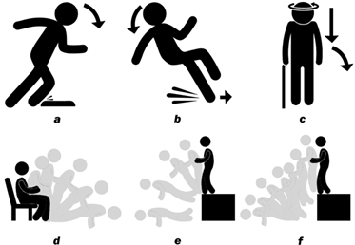

Fig 2.5.3.1 Falling Examples

**Chapter 3: Architecture**

3.1 YOLOv5

The YOLOv5 architecture is built upon a modified version of the DarkNet architecture, which is a neural network designed for object detection and classification. The DarkNet architecture is made up of convolutional layers, pooling layers, and fully connected layers. The YOLOv5 architecture adds several new components, including SPP (Spatial Pyramid Pooling), PAN (Path Aggregation Network), and BiFPN (Bidirectional Feature Pyramid Network) modules.

YOLO architecture mainly consists of three parts:

1. Backbone network: The backbone network is the first part of the YOLOv5 architecture. It is responsible for extracting features from the input image. The backbone network is usually composed of several convolutional layers that are arranged in a specific order. The convolutional layers help to extract low-level features, such as edges and textures, and gradually build up higher-level features, such as shapes and objects. In YOLOv5, the backbone network is based on the CSPDarknet53 architecture, which is a modified version of the DarkNet architecture used in previous versions of YOLO. The CSPDarknet53 architecture has several advantages, including improved accuracy and faster inference times.
2. Neck network: The second component of the YOLOv5 design is the neck network. In order to create a feature pyramid that can be utilised for object identification and classification, it combines the features that the backbone network extracted. SPP (Spatial Pyramid Pooling), PAN (Path Aggregation Network), and BiFPN (Bidirectional Feature Pyramid Network) are a few of the modules that make up the neck network. While the PAN module is used to aggregate information across many scales, the SPP module is used to extract features at numerous scales. A bidirectional feature pyramid that can be used for object identification and classification is made using the BiFPN module. The precision of the YOLOv5 architecture is greatly enhanced by the neck network.
3. Head network: The third and last component of the YOLOv5 design is the head network. Predicting the location and type of objects in the supplied image is its responsibility. A number of convolutional layers are often included in the head network, which is then followed by a number of fully linked layers. The fully connected layers are used to forecast the location and class of objects, while the convolutional layers are used to extract features from the feature pyramid that the neck network constructed. Convolutional layers, batch normalisation layers, and activation layers are some of the layer types that make up the head network in YOLOv5. For each object in the input image, the head network is programmed to produce a set of bounding boxes and the accompanying class probabilities.

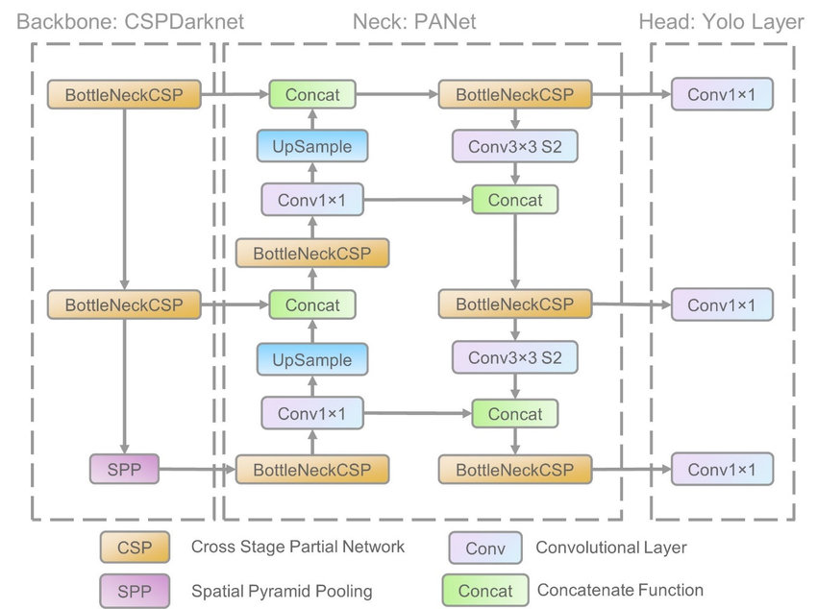

Fig 3.1.1 YOLOv5 Diagram

The Kaggle fall dataset was used to train the YOLO V5S model. More than 550 photos make up the whole dataset. Our model has been trained in a way that makes it more accurate than earlier versions. In order for our model to distinguish between persons kneeling to tie their shoelace and falling over, we additionally trained it using a highly specialised bespoke dataset. We have taken into account several of these circumstances and trained the model in order to lower the error rate when identifying what is regarded to be a fall and what is not.

3.2 ESP32 camera

The architecture of the ESP32 camera includes the following components:

1. CPU: A dual-core Tensilica LX6 microcontroller with clock rates of up to 240 MHz powers the ESP32 camera.
2. Memory: The ESP32 camera has 520 KB of SRAM and 4 MB of flash memory for program and data storage.
3. Wi-Fi and Bluetooth connectivity: Wi-Fi 802.11 b/g/n and Bluetooth 4.2 BLE (Bluetooth Low Energy) protocols are supported by the ESP32 camera.
4. Camera:A 1600x1200 pixel maximum resolution is supported by the OV2640 camera sensor included on the ESP32 camera module. Various features like autofocus, white balance, and exposure control are supported by the camera sensor as well.
5. Peripheral interfaces: There are several peripheral interfaces built into the ESP32 camera, including I2C, SPI, UART, ADC, DAC, and PWM. These interfaces can be utilised to link to extraneous components such sensors, displays, and motors.
6. Power management: The ESP32 camera incorporates a power management unit (PMU) that enables efficient power use by managing the voltage and current levels.

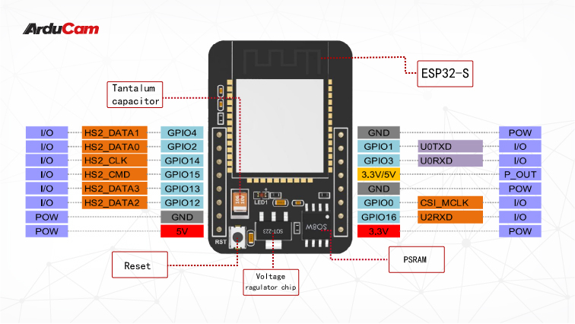Fig 3.2.1 ESP32 Pin Diagram

The ESP32 camera module is made up of a number of components that work together to process the camera data and take pictures and videos. The principal parts are broken down in depth below:

(i) OV2640 Camera Sensor: A 2 megapixel OmniVision OV2640 camera sensor is part of the camera module. It can record photos and videos with resolutions as high as 1600x1200 pixels. The SCCB bus, a two-wire serial interface akin to I2C, is used by the camera sensor to connect to the ESP32 microcontroller.

(ii) ESP32 Microcontroller: The camera module's primary processing component is the ESP32 microcontroller. It has a dual-core Xtensa LX6 CPU with a maximum clock speed of 240 MHz. The microprocessor's multitasking capabilities make it the perfect choice for applications that need to handle camera data in real-time. For storing code and data, the ESP32 microcontroller additionally has 520KB of SRAM and 4MB of flash memory.

(iii) Wi-Fi and Bluetooth Module: The ESP32 camera module includes a built-in Wi-Fi and Bluetooth module, which enables it to communicate wirelessly with other devices. The Wi-Fi module supports 802.11 b/g/n protocols and can operate in both station and access point modes. The Bluetooth module supports both classic and low-energy Bluetooth protocols.

(iv) Power Management Unit: The power management unit is in charge of controlling the power supply to the various camera module components. The module has a number of power-saving capabilities, including a deep sleep mode that allows it to use as little as 10uA of power while it is not actively processing data.

(v) Peripheral Interfaces: In addition to UART, I2C, SPI, and I2S, the ESP32 camera module has a variety of other interfaces. With the use of these interfaces, it may communicate with a variety of external devices, including sensors, displays, and memory units. Communication with the camera sensor occurs through the SPI interface, whilst setting up the camera is done over the I2C interface.

(vi) Camera Driver: A software library called the ESP32 camera driver offers a low-level interface to the camera sensor. It has tools for setting up the camera, customising its settings, and taking pictures and videos. Additionally, characteristics like white balance, exposure, and colour saturation are supported by the camera driver.

(vii) Image Processing: Basic image processing tasks like resizing, cropping, and rotating can be carried out by the hardware-accelerated image processing unit that is part of the ESP32 camera module. The image processing unit can be utilised to process the camera data in real-time, which is beneficial for applications such as object detection and facial recognition.

3.3 Firebase

In order to give developers a scalable and adaptable platform for creating and running mobile and online apps, Firebase architecture was created. At its heart, Firebase comprises of numerous backend services that are meant to interact smoothly together, allowing developers to focus on designing their applications without worrying about the underlying infrastructure.

Principal elements of the Firebase architecture are as follows:

Realtime Database: The Firebase Realtime Database is a NoSQL database that is hosted in the cloud and gives developers access to real-time data syncing and storing. It employs WebSockets to enable real-time synchronization, which means that data changes are quickly disseminated to all connected clients. Because of this, it is perfect for creating real-time applications like chat programs, multiplayer games, and team-building tools.

Cloud Storage: Developers may store and serve user-generated content including photographs, videos, and audio files with Firebase Cloud Storage, a scalable and secure object storage service. It has built-in security features like access control and encryption, making it simple for developers to safeguard the data of their customers.

Hosting: online developers can easily launch their online applications with only one command thanks to Firebase Hosting, a quick and dependable web hosting service. Delivering high-performance online apps to people all around the world is simple because to the built-in support for HTTPS, custom domains, and CDN caching.

Authentication: With just a few lines of code, developers can add user authentication to their applications using Firebase Authentication, a safe and simple authentication service. It supports a variety of authentication methods, including email and password, Google, Facebook, Twitter, and GitHub.

Firebase Cloud Functions' "Cloud Functions" feature enables programmers to execute server-side code in reaction to events that take place within their applications. Developers can do this without having to run their own servers and apply unique business logic to their applications.

Analytics: Firebase Analytics is a robust analytics tool that gives developers with insights into how users are interacting with their applications. Developers are able to optimise their apps depending on user behaviour thanks to the real-time reporting, event tracking, and user segmentation it offers.

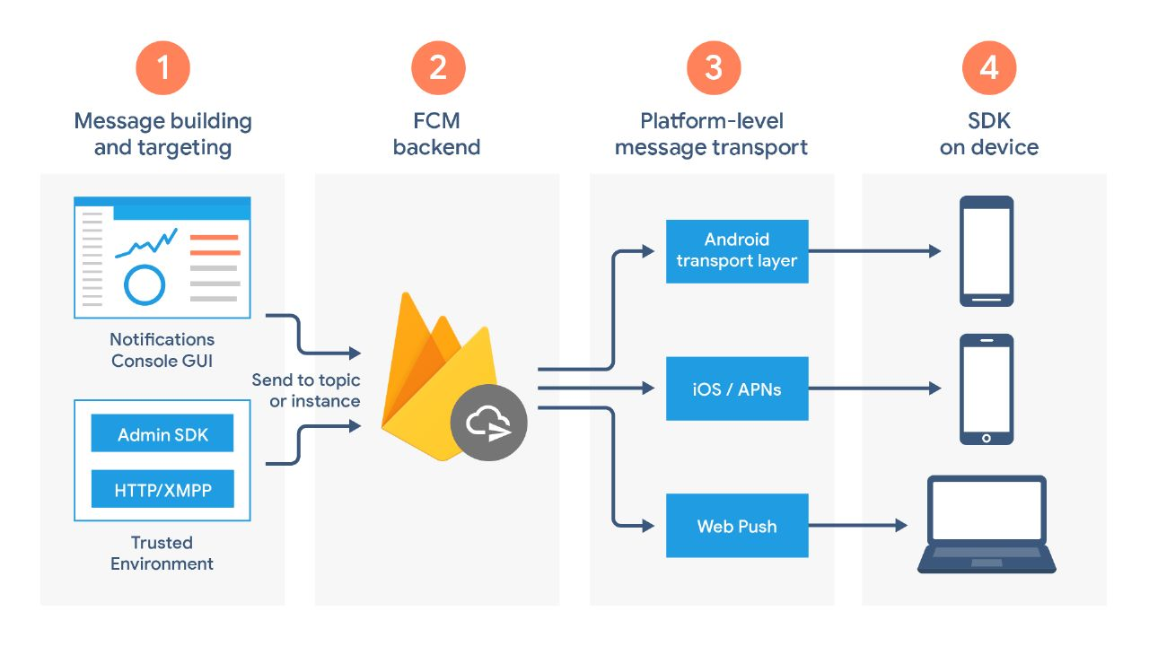

3.3 Proposed Model

The esp32 camera is placed inside a portable box which is made from a 3D-printer. The box has a handle and can be placed anywhere at our desired location. The esp32 camera will record the video in a continuous manner and feed to the YOLOv5s algorithm. The YOLOv5s algorithm will analyze the live feed that is received from the camera and based on that it will detect falling, walking and sitting.

If walking or sitting is detected then the video input is analyzed further and no further action is taken. If falling is detected in the livestream then a message “Fall Detected” and the location is sent to the concerned users.

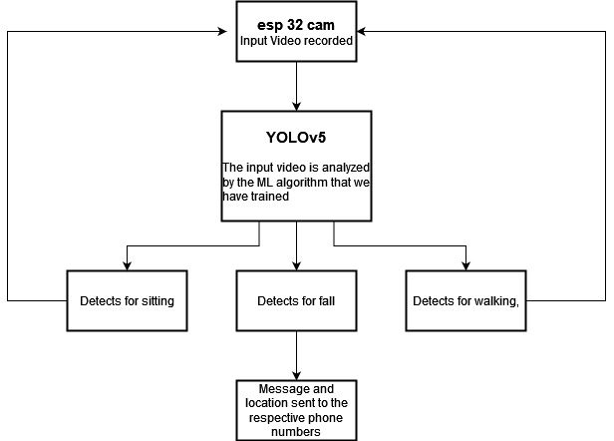

Fig 3.3.1 Architecture of our Model

**Chapter 4: Implementation**

4.1 Camera Input

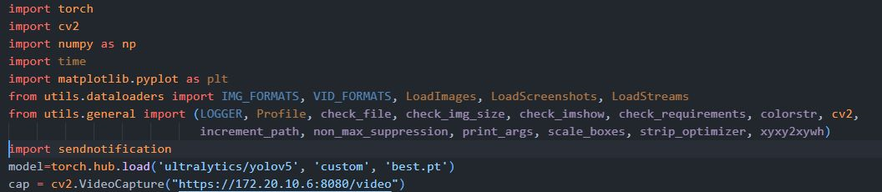

Fig 4.1.1 ESP32 Code

This part of the code allows us to record videos through our ESP32 camera. As we can see, opencv helps us to capture the live recording of our stream. The ip address which is given in the code is used to access the livestream as recorded by the esp32 camera which is then analyzed by our YOLOv5s model.

4.2 Detection

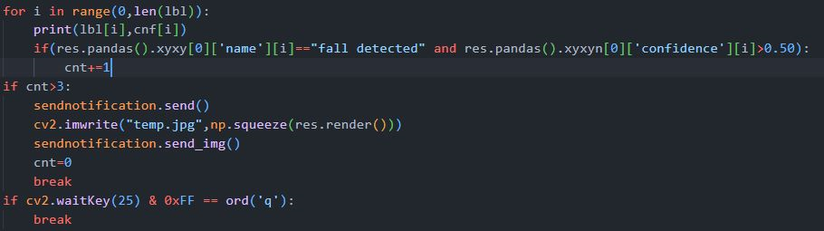

Fig 4.2.1 Detection Code

This part of the code is responsible for detecting if the user is currently walking, sitting or if the user has fallen. The livestream video that we get from the esp32 camera then forwarded to our YOLOv5s model which analyzes the video at a rate of one frame per second. As seen in the code we have kept a condition that the confidence rate should be greater than 0.5, this improves the accuracy of our model and only if the count value is greater than 3 which means if the model detects fall in more than 3 frames, we decide that fall has been detected. As soon as fall has been detected a notification will be sent to the respective people.

4.3 Alert System

After analyzing the livestream with the help of our YOLOV5 model we will detect fall, sitting or walking. When fall has been detected by the model we will be sending an alert or a notification to the respective numbers.

4.3.1 Telegram

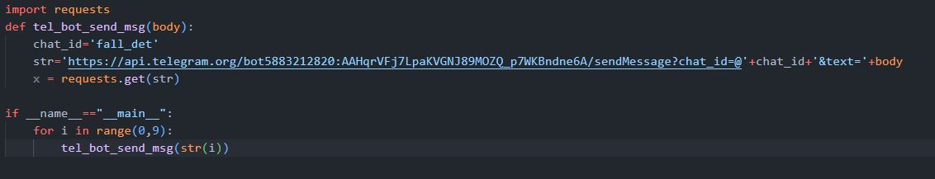

Fig 4.3.1.1 Telegram API Code

The above code snippet is for sending notifications to the telegram users. We have used the telegram API for this purpose which helps us to send notifications to the respective users. We will not only be sending the notification saying the fall has been detected but we also will be sending the location where the impact has happened.

4.3.2 Whatsapp

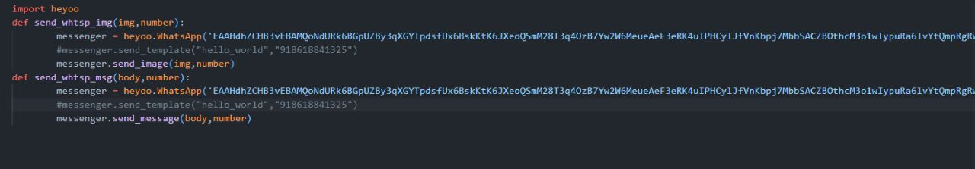

Fig 4.3.2.1 Whatsapp API Code

The above code snippet is used for sending notifications to users through Whatsapp. As seen in the above code for telegram, as soon as the count is more than three we will be sending a “Fall Detected” message. Along with this we will also be sending the gmap location of the impact place.

4.4 Database

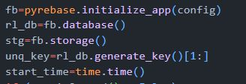

Fig 4.4.1 Firebase Intialization Code

We declare the objects to initialize the objects for the firebase database and storage. We also store the unique key and start time over here.

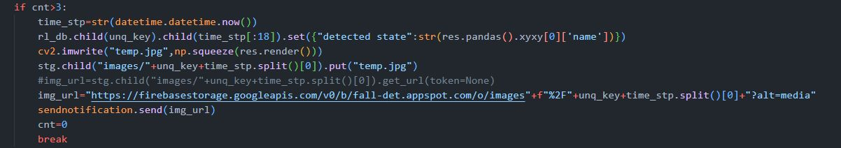

Fig 4.4.2 Firebase condition to store image and send URL to user

.We have designed the system in such a way that the system detects fall if the count value is above three which means our model has detected fall in more than 3 frames of the livestream video and thus fall has been detected. We apply the same condition of count over here. So when count is is greater than three, at that instance we take the snapshot of that particular image and save it in our database. The URL of stored image is sent to the user through whatsapp and telegram notification.

This makes our system a fail proof system. By sending the URL of the image to the user the user can check if the fall detected by the machine is true or not.

**Chapter 5: Results**

ESP32 CAM:

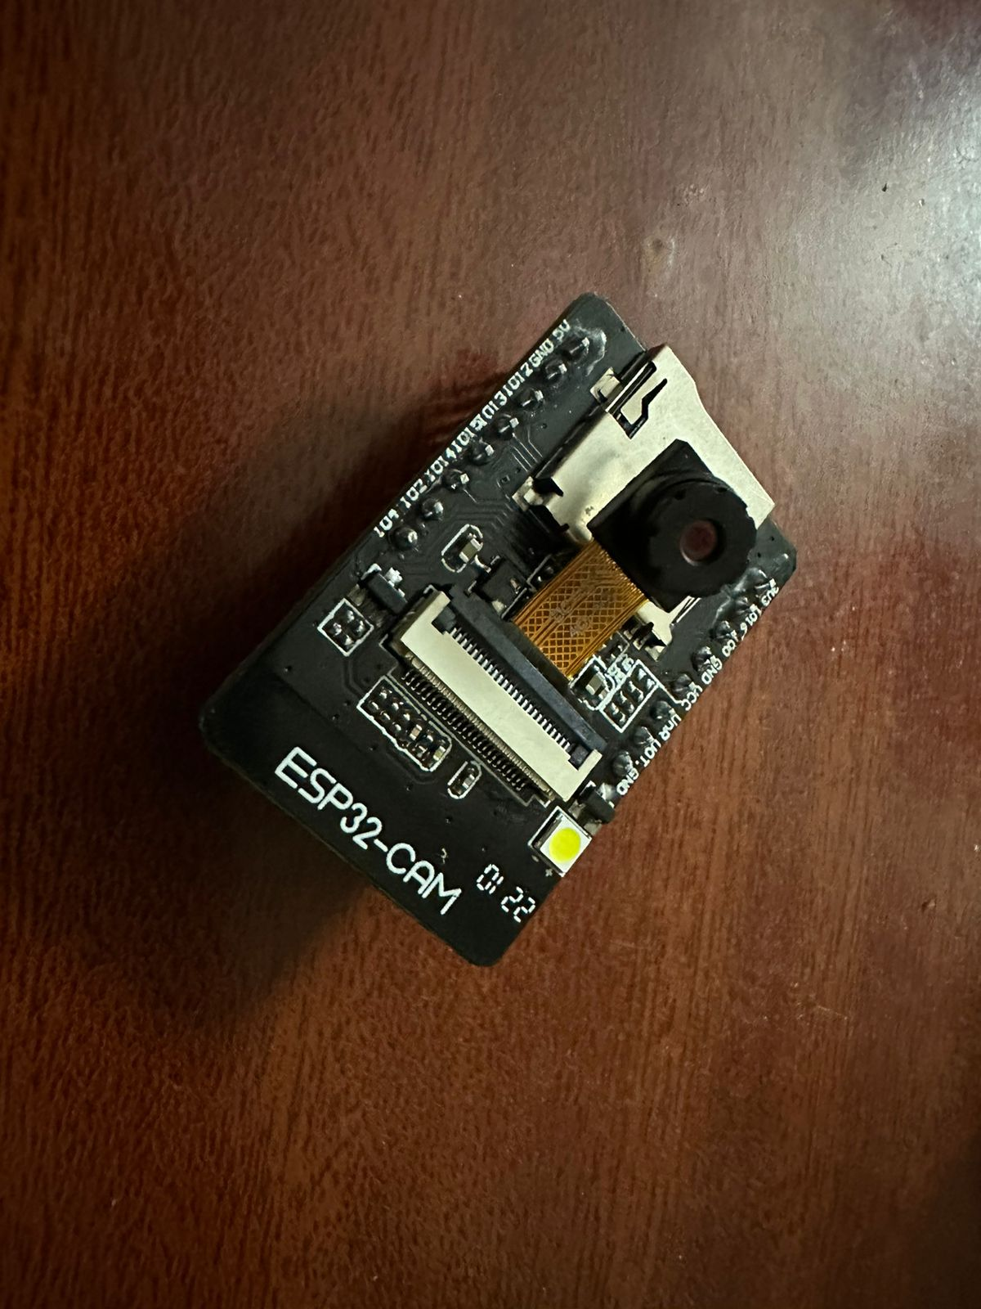

Fig 5.1 Camera

3D-Printed Case:

| Fig 5.2 Camera Shell |
| --- |
| Fig 5.3 Camera Shell |

ESP32 placed inside the case:

| Fig 5.4 Camera inside Shell |
| --- |
| Fig 5.5 Camera inside Shell |

Walking and Sitting Detected:

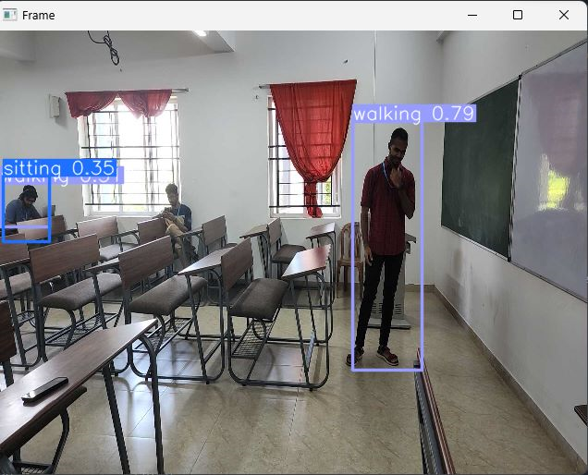

Fig 5.6 No Detection of Fall

Fall Detected:

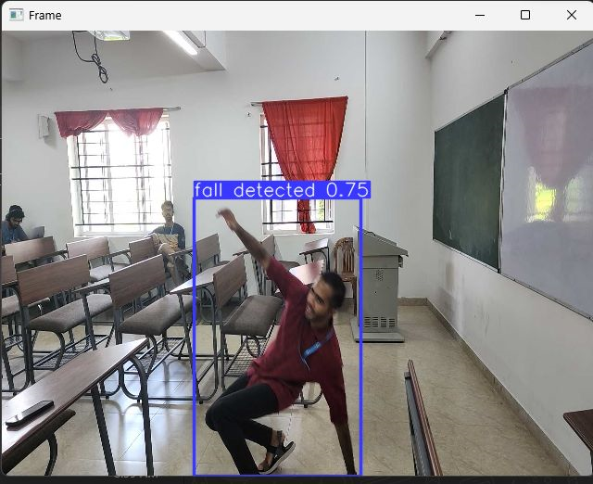

Fig 5.7 Detection of Fall

Telegram Message and Location:

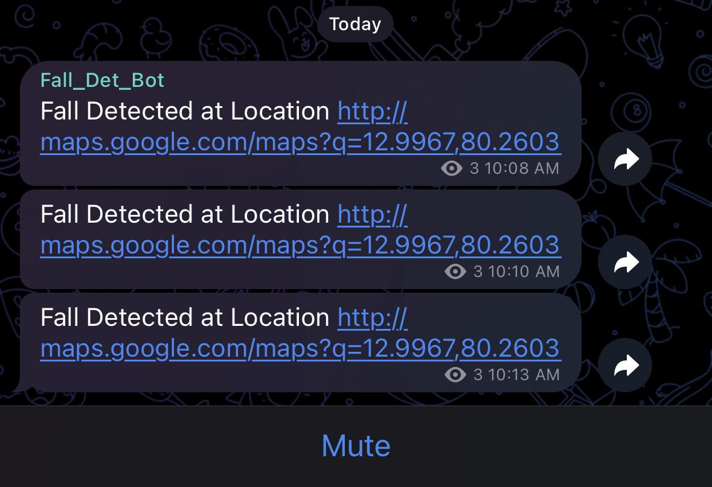

Fig 5.8 Telegram Alert

Whatsapp Message and Location:

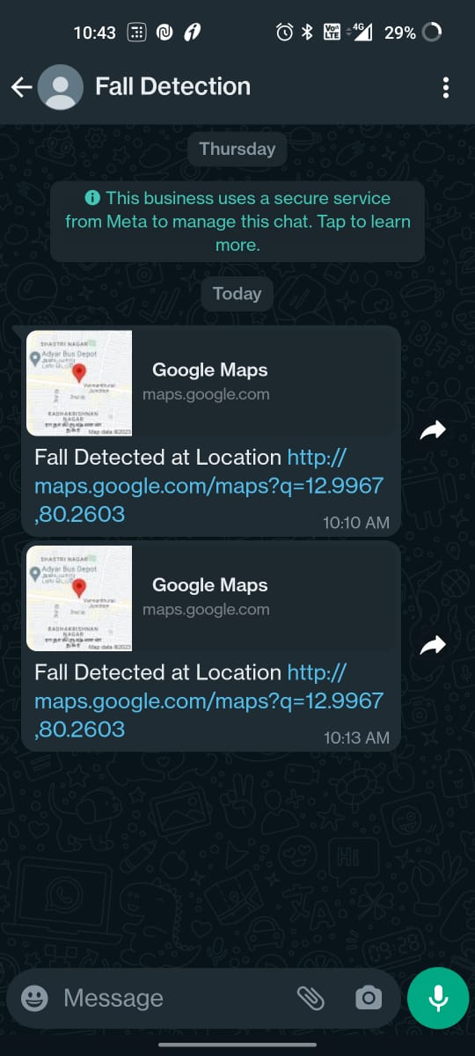

5.9 Whatsapp Alert

Photo saved in URL:

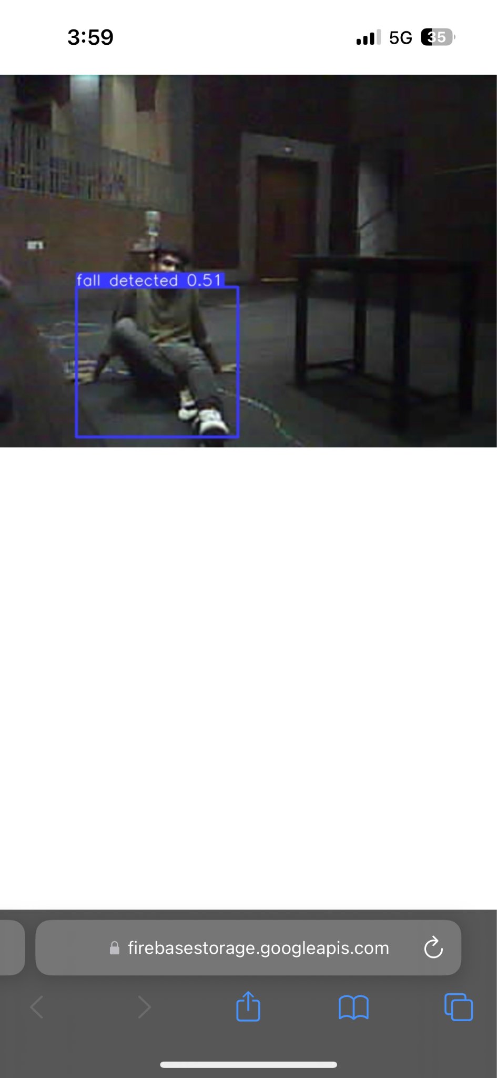

Fig 5.10 URL saved photo

Firebase:

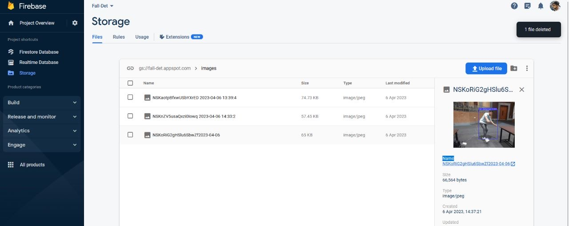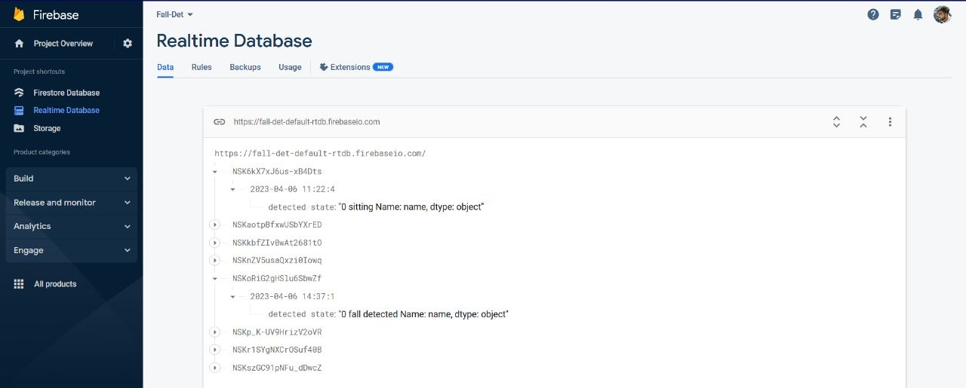

Fig 5.11 Photo stored in Database

YOLO result Models:

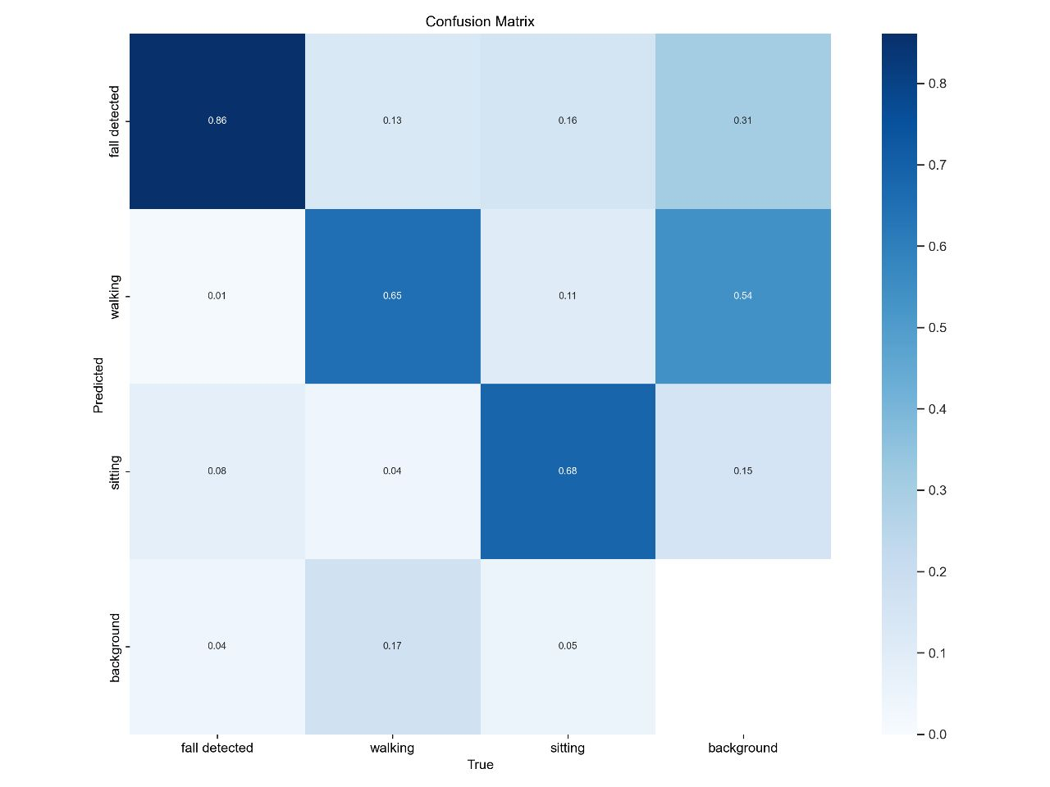

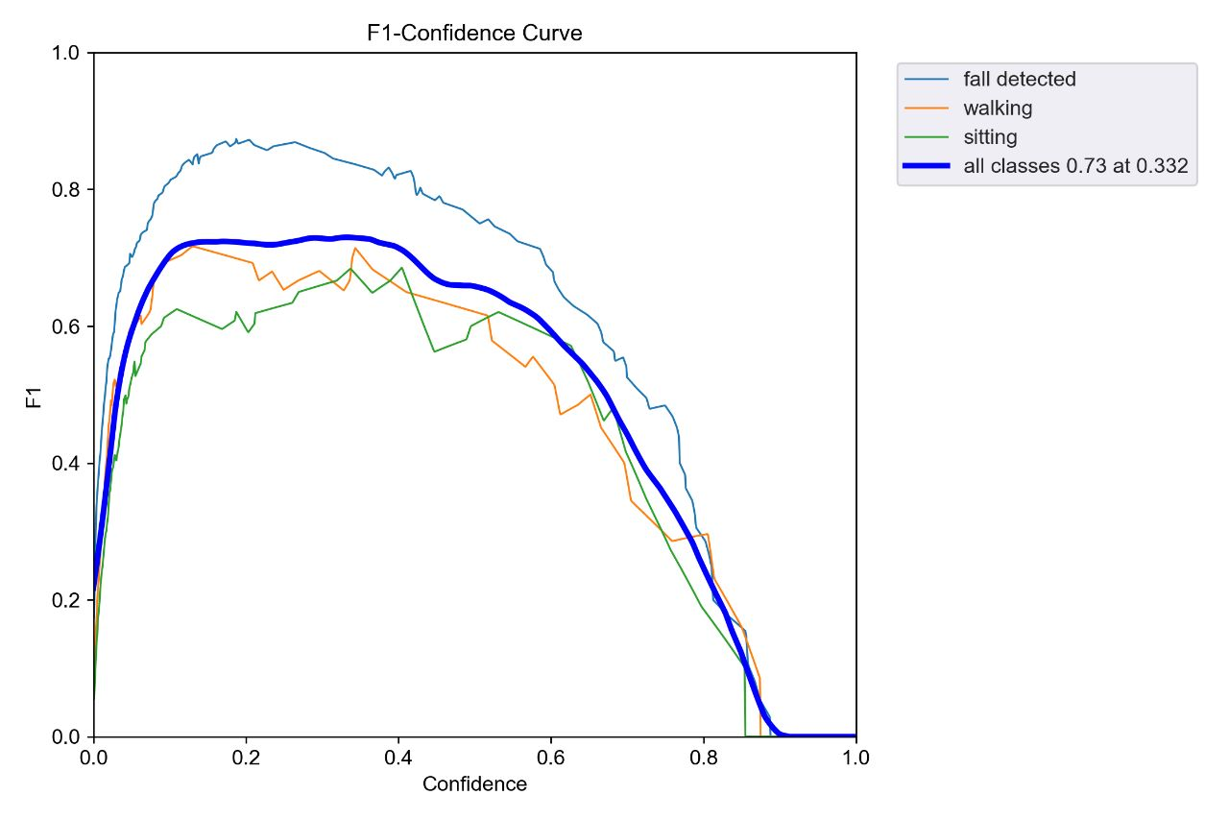

Fig 5.12 YOLO Results

**Chapter 6: Outcomes**

The outcomes of fall detection systems for elderly people can be significant in terms of improving safety and reducing the risk of serious injury

1. Prompt medical attention: One of the main outcomes of fall detection systems is that they can alert caregivers or emergency services when a fall occurs. This can help ensure that the elderly person receives prompt medical attention, reducing the risk of serious injury or complications.
2. Increased independence: Fall detection systems can help elderly individuals maintain their independence and live in their own homes for longer, as they provide an added layer of safety and security.
3. Improved quality of life: Knowing that there is a system in place to detect falls and respond quickly can help reduce anxiety and improve overall quality of life for both the elderly person and their caregivers.
4. Reduced healthcare costs: The cost of fall-related injuries can be significant, and fall detection systems may help reduce healthcare costs associated with falls by preventing more serious injuries and hospitalizations.
5. Valuable data for healthcare professionals: Fall detection systems can provide valuable data to healthcare professionals, enabling them to better understand and prevent falls in the elderly population.
6. Peace of mind: The use of fall detection systems can provide peace of mind to both the elderly person and their caregivers, reducing anxiety and improving overall well-being.

**Chapter 7: Single Unique Factor**

Some of the unique factors in our projects would be:

1. Portability

We can set it up quickly and easily without using any specialised equipment or mounting hardware because it can be hung or positioned anyplace easily. This makes it perfect for usage in a variety of situations, such as at home, at outdoor gatherings, or even when travelling.

Second, our camera's compact size contributes to both its portability and discretion. It is simple to transfer to any location where we need it because it can be simply carried in a backpack, handbag, or even a pocket. Also, because it is small, it won't take up too much room wherever it is put, so it is less likely to be noticed or draw attention to itself.

Overall, our camera is a handy and practical tool for a variety of applications due to its discreet design and portability. Your camera is a dependable and practical alternative whether you want to keep an eye on your house, record video of a particular occasion, or record video while on the go.

1. Cheap

* For many people, especially those trying to find ways to protect the safety of their loved ones, having a camera that is both economical and resource-efficient can be a game-changer. Here are some explanations as to why a low-cost, low-resource camera could be useful in this situation:
* Accessibility: When a camera is affordable and easy to set up, it becomes more accessible to people who might not otherwise be able to buy or utilise a security camera.
* A low-cost camera can be quickly scaled up to fulfil the requirements of various scenarios or surroundings because to its scalability.
* Sustainability: A camera that uses few resources can assist security systems have a smaller negative impact on the environment. These cameras can lessen waste and carbon emissions by utilising fewer resources, such as energy and materials.

1. Higher Accuracy

By examining changes in the person's posture and movement, our camera can identify falls. The sensors in the camera, for instance, can pick up on the rapid shift in posture that occurs when someone falls.

A very accurate camera can not only detect falls but also give useful information about the fall. For instance, the camera can identify the place and moment of a fall.

In general, a high-accuracy camera can greatly enhance fall detection and assist in avoiding major injuries. The camera can swiftly and precisely identify falls using cutting-edge image processing methods and machine learning algorithms.

1. Real Time Alert System

The use of WhatsApp and Telegram APIs can enable us to send notifications to relatives or neighbors when a person falls and gets detected by the camera. Once the camera is set up, we can integrate it with the WhatsApp and Telegram APIs. This is done using API keys that are provided by WhatsApp and Telegram. When the camera detects a person falling, it triggers an event that will activate the API and send the message to the designated recipients.

**Chapter 8: Future Work**

Fall detection systems have the potential to improve the safety and quality of life for elderly individuals and those with mobility impairments. Here are some potential areas of future work in fall detection systems:

1. Improving accuracy: While current fall detection systems have shown promising results, there is still room for improvement in terms of accuracy. Future research could focus on refining algorithms and integrating new sensor technologies to enhance the accuracy of fall detection systems.
2. Integration with health monitoring: Fall detection systems could be integrated with other health monitoring systems to provide a more comprehensive view of an individual's health. For example, fall detection sensors could be integrated with heart rate monitors or blood pressure sensors to detect changes in vital signs that could indicate a fall or other health issue.
3. Privacy and data security: As with any technology that collects and stores sensitive data, fall detection systems need to address concerns about privacy and data security. Future research could focus on developing secure data storage and transmission methods, as well as strategies for managing data access and use.
4. User-friendly interface: To ensure widespread adoption, fall detection systems need to be easy to use and integrate seamlessly into users' daily lives. Future research could focus on developing user-friendly interfaces and integration with popular devices, such as smartphones or smartwatches, to make fall detection systems more accessible and convenient for users.

**Chapter 9: Sample Code**

Code Link:

https://github.com/Nav1203/tarp-fall

**Chapter 10: Conclusion**

A dependable and efficient fall detection system is becoming more and more necessary as our population ages.

In addition to lowering the chance of catastrophic harm from falls, these devices can give older people and their carers a sense of security and peace of mind. In conclusion, by enhancing their safety and freedom, elderly people can considerably benefit from the development and deployment of fall detection systems. A worthwhile step towards fostering healthy ageing and ensuring that elders may continue to lead satisfying lives is investing in such systems, too.

Due to their great accuracy and resilience, deep learning-based fall detection systems have attracted a lot of attention recently. One such deep learning model with promising outcomes in fall detection applications is YOLOv5. A single neural network is used by the cutting-edge object detection model YOLOv5 to forecast bounding boxes and class probabilities for each object in an image. This model has a high level of accuracy in object detection tasks, including fall detection. When using YOLOv5 to detect falls, the algorithm must be trained on a dataset of pictures and videos of falls and non-falls.

Overall, YOLOv5 has the potential to dramatically increase elderly people's safety and quality of life when used for fall detection. It is crucial to remember that the system is not perfect and might not catch all falls. In order to lower the risk of falls, it should be used in concert with other fall prevention strategies such regular exercise and home modifications.

**Chapter 11: References**

1. De Miguel, K. A., Brunete, A., Hernando, M., & Gambao, E. (2017). Home Camera-Based Fall Detection System for the Elderly. *Sensors*, *17*(12), 2864. <https://doi.org/10.3390/s17122864>
2. Wu, F., Zhao, H., Zhao, Y., & Zhong, H. (2015). Development of a Wearable-Sensor-Based Fall Detection System. *International Journal of Telemedicine and Applications*, *2015*, 1–11. <https://doi.org/10.1155/2015/576364>
3. Shu, F., & Shu, J. (2021). An eight-camera fall detection system using human fall pattern recognition via machine learning by a low-cost android box. *Scientific Reports*, *11*(1). <https://doi.org/10.1038/s41598-021-81115-9>
4. Chen, M., Cheng, Y., & Chen, R. (2021). Improve the Accuracy of Fall Detection Based on Artificial Intelligence Algorithm. *Cmes-Computer Modeling in Engineering & Sciences*, *128*(3), 1103–1119. <https://doi.org/10.32604/cmes.2021.015589>
5. Mankodiya, H., Jadav, D., Gupta, R., Tanwar, S., Alharbi, A. G., Tolba, A., Neagu, B., & Raboaca, M. S. (2022). XAI-Fall: Explainable AI for Fall Detection on Wearable Devices Using Sequence Models and XAI Techniques. *Mathematics*, *10*(12), 1990. <https://doi.org/10.3390/math10121990>
6. *An Algorithm of Fall Detection Based on Vision*. (2021, June 1). IEEE Conference Publication | IEEE Xplore. <https://ieeexplore.ieee.org/abstract/document/9644427>
7. Jiao, S., Miao, T., & Guo, H. (2021, January 1). *Image Target Detection Method Using the Yolov5 Algorithm*. Smart Innovation, Systems and Technologies.
8. *An enhanced fall detection system for elderly person monitoring using consumer home networks*. (2014, February 1). IEEE Journals & Magazine | IEEE Xplore. <https://ieeexplore.ieee.org/abstract/document/6780921>
9. *Improved YOLOv5 Method for Fall Detection*. (2022, December 16). IEEE Conference Publication | IEEE Xplore. <https://ieeexplore.ieee.org/abstract/document/10006129>
10. *Elderly Fall Detection Based on Improved YOLOv5s Network*. (2022). IEEE Journals & Magazine | IEEE Xplore. <https://ieeexplore.ieee.org/abstract/document/9868788>
11. *Fall Detection Algorithm for the Elderly based on YOLOv5s*. (2022, May 1). IEEE Conference Publication | IEEE Xplore. <https://ieeexplore.ieee.org/abstract/document/9887608>
12. *Fall detection system based on real-time pose estimation and SVM*. (2021, March 26). IEEE Conference Publication | IEEE Xplore. <https://ieeexplore.ieee.org/abstract/document/9390068>
13. *Research on Fall Detection Algorithm for the Elderly Living Alone Based on YOLO*. (2021, November 22). IEEE Conference Publication | IEEE Xplore. <https://ieeexplore.ieee.org/abstract/document/9696459>
14. Jiao, S., Miao, T., & Guo, H. (2021). Image Target Detection Method Using the Yolov5 Algorithm. *Smart Innovation, Systems and Technologies*, 323–329. <https://doi.org/10.1007/978-981-16-3180-1_40>
15. *Camera based Activity Recognition for Assisted Living Applications*. (2022, October 25). IEEE Conference Publication | IEEE Xplore. <https://ieeexplore.ieee.org/abstract/document/9935136>
16. *Comparative study of YOLOv3 and YOLOv5’s performances for real-time person detection*. (2022, March 3). IEEE Conference Publication | IEEE Xplore. https://ieeexplore.ieee.org/abstract/document/9737924